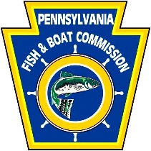
Sinnemahoning Creek Watershed Restoration Grant Program
2020 Request for Proposals and Grant Application Package

This package guides potential applicants to the Pennsylvania Fish and Boat Commission’s Sinnemahoning Creek Watershed Restoration Grant Program (PFBC SCWRG Program). Part A describes the program being implemented, including qualifications for grants. Part B contains the application checklist, applicant and project information, expected content for the project description, application data sheets, and any accompanying instructions for completing the application. Part C describes the evaluation system used by PFBC for grant applications.

PART A: Restoration Grant Program Information and Instructions

Before an applicant completes the application form (Part B), it is important to read Part A to ensure that (1) the project is of the type that may be funded by the Program, and (2) the applicant understands how the Program will be administered. This Part provides information regarding the following issues:
- Purpose of the Restoration Fund
- Projects Eligible for Funding
- Funding Priorities
- Pre-application Contacts
- Dates and Locations for Submission of Applications
- Eligible Applicants
- Process Used by the PFBC to Evaluate Applications
- Terms, Size, and Conditions of Grants

Purpose of Restoration Fund

On June 30, 2006, approximately 31 rail cars of a train operated by Norfolk Southern Corporation derailed near Gardeau, in Norwich Township, McKean County, Pennsylvania. The derailment resulted in sodium hydroxide spilling into the environment that caused damage to the natural resources of Big Fill Run, Sinnemahoning-Portage Creek and the Driftwood Branch of Sinnemahoning Creek.

Thereafter, the Commonwealth of Pennsylvania and Norfolk Southern reached a settlement agreement. As part of the settlement, Norfolk Southern agreed to pay the Commonwealth $7,350,000 as restitution for the natural resource damages that occurred. The Commission received one-half of that amount or $3,675,000 and under the settlement must utilize the funds (minus its investigative and response costs of $93,000) for purposes of developing and implementing projects that benefit recreational fishing and boating and the aquatic resources of Cameron, McKean, Elk and Potter Counties.

Projects Eligible for Funding

To be eligible, projects must be located in and benefit fishing, boating and the aquatic resources of Cameron, McKean, Elk or Potter County. For this grant round, eligible projects must be full and complete to provide a tangible, functional end-product. Preliminary stages/phases (e.g., assessment, monitoring, design, permitting or some other component) of a larger on-the-ground project will not be considered eligible unless the comprehensive end-product is completed as an integral part of the project grant. However, if a fully functional end-product using component stages/phases already accomplished with other funding sources will be delivered as a result of the grant, then the project will be eligible for funding. In addition, eligible projects must occur on lands owned by the applicant in fee simple or where the applicant has a long-term lease or other agreement with the landowner for the site. The nature and the duration of the applicant’s interest in the property will be determined by the project type. As a condition of a grant, the PFBC will require that the project site be kept open and accessible to the public at reasonable hours and times of the year consistent with the nature and intended use of the site.

Funding Priorities

The PFBC has identified the following priority project types for funding under the current round of grant awards for the SCWRG Program. Only grant applications that propose projects that address one or more of the following priority project types will be considered. Note that this limited number of project types has not changed since the last round of awards. All are of equal priority, so the listing sequence below is not indicative of their priority. As determined necessary by the PFBC, priority project types eligible for funding may be revised in future grant rounds – if there are any. Based on the remaining balance of uncommitted funds, this round is likely to be the last for this specific grant program.

- Natural stream channel and bank restoration or lake/reservoir/pond projects that provide public fishing access and maintain or improve water quality and/or habitat for fish and other aquatic life. Eligible costs include:
  - Project planning and design.
  - Project construction.
  - Assessment of the impacts of the project on aquatic life, and aquatic life habitat.
  - Maintenance activities on new or existing projects.

- In-stream habitat modifications that restore/enhance aquatic wildlife/fish passage at barriers to migration including projects to remove/replace culverts, or to remove dams, water obstructions, or encroachments that restrict habitat connectivity. Eligible costs include:
  - Project planning and design.
  - Project construction.
  - Assessment of the impacts of the project on aquatic life, and aquatic life habitat.
  - Maintenance activities on new or existing projects.

- Riparian buffer installation and/or improvement. Eligible costs include:
  - Purchase price of property (fee simple or easement). See item number 6 for eligible acquisition costs.
  - Project planning and design.
  - Project construction activities including materials, supplies and contracted services.
  - Assessment of the impacts of the project on aquatic life and aquatic life habitat.
  - Maintenance activities on new or existing projects.

- Abandoned mine drainage treatment systems or mine reclamation projects that result in significant improvements to water resources that are likely to benefit fish and other aquatic life.
  - Project planning and design.
  - Project construction activities.
  - Operation and maintenance of new projects, as well as operation, maintenance, and replacement of existing projects.
  - Assessment of the impacts of the project on aquatic life and aquatic life habitat.

- Acquisition and development of property (fee simple or easements) for public access, conservation and environmental improvement purposes. Eligible costs include:
  - Purchase price.
  - Associated legal, recording, and settlement costs.
  - Preparation of the baseline document for easements. This will be required for all easement projects.
  - Title insurance, environmental assessments and appraisals.
  - Public fishing and boating access development, including design, engineering and construction.
  - GIS mapping and surveying.
  - One time stewardship endowment cost for monitoring and enforcement of easement agreements
  - Maintenance activities.

- Enhancement or restoration of populations of aquatic Species of Greatest Conservation Need (SGCN) with State Status Rank of S3, S2, or S1 and species that are of Regional Responsibility within the Northeast United States (i.e., secure in PA, but extirpated or rare and declining elsewhere in this region) that are conserved and managed under the jurisdiction of the PFBC and are identified in the 2015 Pennsylvania Wildlife Action Plan – and limited to the following species:

FISH | MUSSELS | AMPHIBIANS
Allegheny Burbot | Brook Floater | Eastern Hellbender
Allegheny Pearl Dace | Creek Heelsplitter | Mudpuppy
American Eel | Elktoe
Bigmouth Shiner | Green Floater
Brook Trout | Long-solid
Longhead Darter | Round Pigtoe
Mountain Brook Lamprey | Wavy-rayed Lampmussel
Redside Dace
Tonguetied Minnow

For additional information, please see http://fishandboat.com/swap.htm - especially the species accounts found in Appendix 1.4.

Eligible costs include:
  - Project planning and design – including costs associated with obtaining Pennsylvania Natural Diversity Inventory (PNDI) clearance from all jurisdictional agencies.
  - Project implementation/construction.
  - Mussel species propagation, translocation, and reintroduction – limited solely to the aforementioned mussel species.
  - Conservation or population enhancement measures that benefit the host fishes for the aforementioned eligible mussel species will be considered.
  - Assessment of the effects of the project on aquatic SGCN habitat and population – including aquatic SGCN population monitoring to determine presence, abundance, distribution, translocation/reintroduction survivorship, and reproductive success.

- Storm water conservation practices/best management practices that maintain or improve water quality and/or habitat for fish and other aquatic life. Eligible costs include:
  - Project planning and design.
  - Project construction.
  - Maintenance activities on new or existing projects.
  - Environmentally sensitive dirt and gravel road maintenance – limited to Environ-mentally Sensitive Maintenance (ESM) practices/best management practices eligible for funding from the PA Dirt and Gravel Road Maintenance Program and described in the publication “Environmentally Sensitive Road Maintenance Practices for Dirt and Gravel Roads” (U.S.D.A., Forest Service, National Technology & Development Program, publication # 1177 1802; April 2012; online at https://www.fs.fed.us/eng/pubs/pdf/11771802.pdf ). NOTE: road paving with Driving Surface Aggregate (DSA) is eligible for funding; however, paving with asphalt or concrete or tar-and-chip is ineligible for funding. Except for road paving or sealing, ESM for Low Volume Roads is eligible.
  - Assessment of the impacts of the project on aquatic life and aquatic life habitat.

- Acid deposition abatement and alkaline addition to remediate adverse impacts from acidic precipitation to habitat for fish and other aquatic life. Eligible costs include:
  - Pre-project assessment and sampling.
  - Planning and design activities.
  - Alkaline addition activities (automatic lime dosers, accepted land liming methods, etc.).
  - Assessment of the impacts of a remediation project on aquatic life and aquatic life habitat.

Eligible Applicants

To be eligible, applicants must meet one of the following criteria. Although the applicant does not have to be located in Cameron, McKean, Elk or Potter County, the project has to be implemented in one of those counties.

- Commonwealth and federal agencies involved with the protection and conservation of environmental resources and fish/wildlife habitat;
- Counties and municipalities (boroughs, townships, etc.);
- County Conservation Districts;
- Councils of Government;
- Watershed/conservation organizations that promote local watershed/conservation efforts;
- Other organizations involved in research, restoration, rehabilitation, planning, acquisition, development, land conservation, education or other activities that further the protection, enhancement, conservation, preservation or enjoyment of Pennsylvania's environmental, conservation, recreation or similar resources.
Note: Non-governmental organizations must meet all of the following criteria in order to be eligible for funding:
- The organization’s bylaws must indicate that its charitable purpose includes the preservation or conservation of critical habitat, open space, watersheds, rivers and streams, or natural areas for public benefit.
- The organization must be incorporated with the Pennsylvania Department of State, Bureau of Corporations
- The organization must be tax-exempt under Section 501 (c)(3) of the Internal Revenue Code of 1986.
- The organization must be registered with the Pennsylvania Department of State, Bureau of Charitable Organizations. This requirement will be waived for grant requests of less than $5,000.
- The organization must be in existence for at least 5 consecutive years.
- For acquisition projects, the organization must have a track record of acquisition experience.

Ineligible Applicants

Ineligible applicants include individuals, private for-profit firms and others that do not fall within the eligibility categories.

Process Used by PFBC to Evaluate Applications

Applications will first be reviewed for applicant eligibility and completeness. Although the PFBC will attempt to obtain missing information from the applicant, it is the applicant’s responsibility (and not that of the PFBC) to ensure that submitted application packages are complete, and the provided checklist needs to be used to accomplish this end. Incomplete applications will not be considered in the evaluation process. The PFBC may request supplemental information and/or a site visit if it determines that such information is necessary to assist in evaluating an application. Applications will be scored using the system described below in Part C.

Size, Terms, and Conditions of Grants

There is no specific limit to the number of projects that may be applied for and selected for a funding award. For the current round, the PFBC will consider individual grant awards in the range of $10,000 to $100,000. However, the PFBC’s decisions regarding particular applications may be determined by the total amount of funds to be made available for the funding round and by the need to accomplish certain objectives. Awarding of funds for any selected projects will be contingent upon availability of funds, so an award may be less than an applicant’s request. It is the applicant’s responsibility to abide by the range of funds to be made available for individual grant awards and by the priority project types specified in this document.

Applicants must secure matching funds equal to at least 25% of the total project costs in order
to supplement PFBC funds and assist in implementing their proposed projects. This minimum match threshold is equal to one-third of the grant amount the applicant is requesting from the PFBC. The 25% match may be in the form of grants from other institutions, cash, in-kind labor, equipment, materials and supplies. PFBC services or grants from other PFBC programs cannot be used as match. In-kind contributions with corresponding dollar value must be documented with a letter from the person(s) or entity providing the contribution.
Volunteer services should be valued at $15.00 per hour. Donated land value is eligible
match for acquisition projects.

A maximum of 10% of the total grant award may be used to cover project-related administrative and overhead costs. Salary and wages are eligible for funding provided a clear link between project implementation is demonstrated.

Applicants typically will be required to complete projects within two years. However, under certain circumstances, the PFBC will grant a time extension.

Applicants must be willing to enter into a cooperative agreement with the PFBC containing standard Commonwealth terms and conditions and others that the PFBC requires.
Applicants will be required to obtain necessary environmental and building permits from appropriate local, state and federal agencies. Where necessary, applicants also will be required to conduct appropriate archeological and historical surveys and all surveys for wetlands and endangered and threatened species. Regardless of whether or not there is a potential project conflict with protected species/natural resources, documentation for PNDI clearance or consultation with the appropriate jurisdictional agencies must be included as part of the grant application. For acquisitions of real property, an environmental assessment and title search must be performed. Costs associated with obtaining required permits and conducting necessary surveys and assessments may be reimbursed to applicants, if requested in the application, or may be considered a matching or in-kind contribution.

Depending on the type of project, applicants may be required to be responsible for long-term maintenance and operation. Applicants seeking funding for fee simple acquisitions must be willing to grant a public fishing and boating access conservation easement to the PFBC or other entity deemed qualified by the PFBC. For easement acquisitions, applicants must be willing to name the PFBC as a co-holder or beneficiary of the easement, whichever is determined by the PFBC to be in its best interests.

Pre-application Contacts

Applicants may contact Jeff Schmid, Fisheries Biologist, Division of Habitat Management, if they have questions about the program or the application process. He can be reached at (814) 359-5242 or contacted via e-mail at jschmid@pa.gov

Date and Location for Submission of Applications

Project applications must be postmarked no later than Saturday, January 23, 2021, and must be mailed to the contact person and address below. Please mail your complete grant application as both a single paper copy and a digital copy (on flash-drive or CD) as a Microsoft Word document. NOTE: E-mailed or faxed applications will not be accepted. The PFBC anticipates final selection and public announcement of grant awards by the end of April 2021.

The completed application package must be submitted by mail to:

Sinnemahoning Creek Watershed Restoration Grant Program
ATTN: Jeff Schmid, Fisheries Biologist
Division of Habitat Management
Pennsylvania Fish & Boat Commission
Centre Region Office
595 East Rolling Ridge Drive
Bellefonte, PA 16823

For more information on this and other PFBC grant programs go to:

http://www.fishandboat.com/Transact/Grants/Pages/default.aspx

PART B. Grant Application Forms and Checklist

A complete application includes all information indicated in the checklist below. The applicant needs to complete and submit this checklist as part of a complete application.

Application and Attachments Checklist
√ |  | Description
 | 1. | Applicant Information
 | 2. | Project Information
 | 3. | Project Description
 | 4. | Project Questions
 | 5. | Project Budget and Matching Amounts

Please Provide the Following as Attachments: (Please label attachments clearly)
 | 6. | Project Area Map
 | 7. | Project Design Drawings or Sketches
 | 8. | Color photographs of the project site (with labeling)
 | 9. | If a Nonprofit Organization, Proof of Legal Status
 | 10. | Letters of Support from Affected Entities or Partners
 | 11. | Current Budget or Most Recent Financial Report
 | 12. | Proof of Ownership or Control of Project Site

Note: The PFBC may request additional information regarding the applicant or project.

APPLICANT INFORMATION (if completing on behalf of a corporation, association or club, that entity is the applicant)
Applicant name:  Address:  E-mail: | Applicant telephone: | Applicant Fax:
Organization name:  Address:  E-mail: | Tax code status:  Federal ID Number:  SAP Vendor Number:
Project contact person name:  Address:  E-mail: | Contact telephone: |  | Contact fax:
The applicant certifies the truth of the statements contained in this application package. The person signing must be authorized by the applicant to sign on its behalf and the applicant must attach satisfactory confirmatory documentation.

Applicant signature: Date:

Please print name here:

PROJECT INFORMATION
Project Title: |  |  |  |  |  |  |  |  |  | Submittal date:

Project type (please check applicable category)

⁫ Stream channel/bank restoration
⁫ In-stream aquatic wildlife/fish enhancement/fish passage
⁫ Riparian buffer installation/improvement
⁫ Abandoned mine drainage treatment systems/mine reclamation
⁫ Property acquisition/development
⁫ Enhancement/restoration of populations of specified Species of Greatest Conservation Need
⁫ Storm water best management practices
⁫ Acid deposition abatement/alkaline addition to improve water quality

Check one:
⁫ Initial Submission ⁫ Resubmission

If resubmission, date application was originally submitted:

Proposed project start date: Project duration:

Amount Requested: |  |  |  |  |  | Matching Amount: |  |  | Total Project Cost:
PFBC use only – Applicants do not complete this section
Date received: |  |  |  |  |  |  | Complete: ⁫ Incomplete: ⁫
Additional information:
 |  | PROJECT DESCRIPTION
 |  | Provide a description of the project, including: (1) a description of baseline conditions, (2) the objectives for the project, (3) a list of tasks that will be undertaken, (4) measureable results and/or desired outcomes, (5) project deliverables (draft and final reports and other project documentation), (6) project schedule including deliverable due dates, and (7) any sketches or conceptual drawings relating to the design of the project, (8) Labeled color photographs of the project site (where applicable, depict and identify specific problems that the proposed project is intended to correct or minimize). (Include the aforementioned content numbers and sequence in your narrative. Attach additional sheets as needed.)
PROJECT QUESTIONS (to be answered as part of the application)
1. |  |  | Provide a paragraph description of your organization’s mission, goals, number of members and prior accomplishments.
2. |  |  | (a) Could this project be undertaken by other watershed programs if the PFBC did not fund this project? If yes, please explain. (b) Is this project required for regulatory reasons? If yes, please explain.
3. |  |  | (a) Are any permits required for the project? If yes, please explain. (b) Have PNDI searches and, if necessary, consultations with jurisdictional agencies been initiated due to potential conflicts with protected species/resources? If yes, please explain and provide copies of clearance or consultation documents. (c) Are any environmental, archeological, or historical surveys required for the project? If yes, please explain. (d) What is the schedule for obtaining appropriate permits and/or surveys?
4. |  |  | Will this project provide any environmental benefits? If yes, please explain the nature of the benefits.
5. |  |  | Will this project provide any benefits in terms of public access? Does this project provide access to an area that is currently closed/posted to the public?
6. |  |  | (a) Will this project require any maintenance after completion? If yes, please explain the type of maintenance required and how it will be accomplished.
7. |  |  | What short or long-term monitoring activities will be implemented to evaluate project success? Please provide the parameters being measured, frequency of sampling, duration of monitoring and describe the relationship between monitoring activities and project success.
8. |  |  | Please provide a quantitative description of permanent improvements to recreational use (e.g. number of people with increased access to stream), in-stream habitat (e.g. number of spawning areas, number of linear feet within stream with improved cover), or other ecological improvements (e.g. gallons of storm water infiltrated per year, number of linear feet of buffer, length of streambank stabilization) expected to result from project implementation.
9. |  |  | Does this project relate to other projects in the watershed or in the vicinity of the project? If yes, please describe the nature of the relationship.
10. |  |  | Provide a map showing where the project will occur and the location of any other related projects in the immediate area. ATTACH MAP TO APPLICATION (if latitude/longitude coordinates are available, please include).
11. |  |  | Identify and describe any partners involved in project development and/or implementation and the roles played by each. Include in your description any matching funds or in-kind contributions.
12. |  |  |  | Provide one-paragraph descriptions for each key person who will be working on this project, indicating name, affiliation, role they will play, accomplishments and qualifications.
 | PROJECT BUDGET AND MATCHING AMOUNTS
 | Category |  |  |  | Description |  |  | Grant Funds Requested |  |  | Match/Contributions and Source  (Cash and/or In-Kind)
 | Salary and Benefits
 | Travel
Equipment/
Supplies
(List each item;
Attach additional sheets if necessary)
 | Construction
 | Contractual
 | Acquisition
 | Administrative*
Other
(Itemize)
 | TOTALS

*May not exceed 10% of total grant request

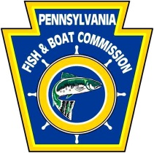
PART C. Evaluation System for Projects

Projects will first be screened to determine whether they qualify for further evaluation. Projects that do not meet the basic screening criteria will be returned to the applicant. Next, the project has to satisfy the threshold criteria. Projects that do not satisfy any one of the threshold criteria listed below will be returned to the applicant. Projects that meet both the screening and threshold criteria will be scored and ranked.
As indicated below, projects that are: located in the immediate area impacted by the spill (Figure 1); specifically address the project type priorities advertised in the Request for Proposals (RFP); provide matching funds that exceed the 25% match requirement; provide additional access to an area for public fishing and/or boating; benefit populations of aquatic Species of Greatest Conservation Need as specified in the RFP; or provide a robust monitoring component or other method to measure success will be scored higher than those that do not.
At the end of the process, the rankings will be divided into three categories of preference; high, moderate, low. This reflects the overall uncertainties in the process and the imprecision of the scoring system below.
Category | Evaluation Questions for Restoration Projects | Score
Screening | Does the applicant meet the eligibility requirements? | Yes No
 | Is the application complete? | Yes No
 | Does the project meet one of the funding priorities as advertised in the PFBC Request for Proposals? | Yes No
Threshold Criteria | Technical feasibility. Is the project technically sound taking into account the level of uncertainty or risk and the experience of the applicant in implementing such projects? | Yes No
 | Is the project consistent with the goals of the Sinnemahoning Creek Watershed Restoration Program? | Yes No
 | Does the proposed project comply with all applicable laws? | Yes No
 | Does the proposed project pose a threat to the health and safety of the public? | Yes No
Scoring  Scoring | Is the proposed project located within the portion of the Sinnemahoning Creek Watershed that was impacted by the train wreck chemical spill (see Figure 1 – area highlighted in green)? | Yes No  5 0
 | Is the proposed project located within the portion of the Sinnemahoning Creek Watershed that was not impacted by the train wreck chemical spill (i.e., within the First Fork Sinnemahoning Creek sub-watershed)? | Yes No  3 0
 | Does the applicant provide more than 25% Match? If so, how much match is provided? | >89% 66-89% 31-65% 26-30% 25%  7 5 3 1 0
 | Do the project cost estimates in the proposed budget seem reasonable and realistic? | Yes No  3 0
 | Is there a robust monitoring component? | Yes No  3 0
 | What is the applicant’s record of performance for prior PFBC grants – including the ability to monitor project results? | 5 3 1 0 -1 -3
 | What is the likelihood of overall project success? | 5 4 3 2 1 0
 | Does the project provide environmental and/or public access benefits? (Score below)
 | - Is the proposed project designed to enhance or restore aquatic Species of Greatest Conservation Need as described and identified in the Request for Proposals? | Yes No  4 0
 | B. Likelihood of permanent increase in public access for recreational use (fishing, boating, other recreation, including existing user increases in satisfaction). | 5 4 3 2 1 0
 | C. Likelihood of permanent out-of-stream ecological improvement of  the watershed (reduced storm water runoff, increased infiltration, riparian enhancement for aquatic life [e.g., wetlands, forested  buffers). | 5 4 3 2 1 0
 | D. Likelihood of permanent instream habitat improvement (improved water quality, improved structural heterogeneity (pools, riffles, runs), improved spawning/breeding areas, improved cover, reduced bank erosion and sedimentation, improved aquatic insect population). | 5 4 3 2 1 0
Total Score: (maximum of 50 points)

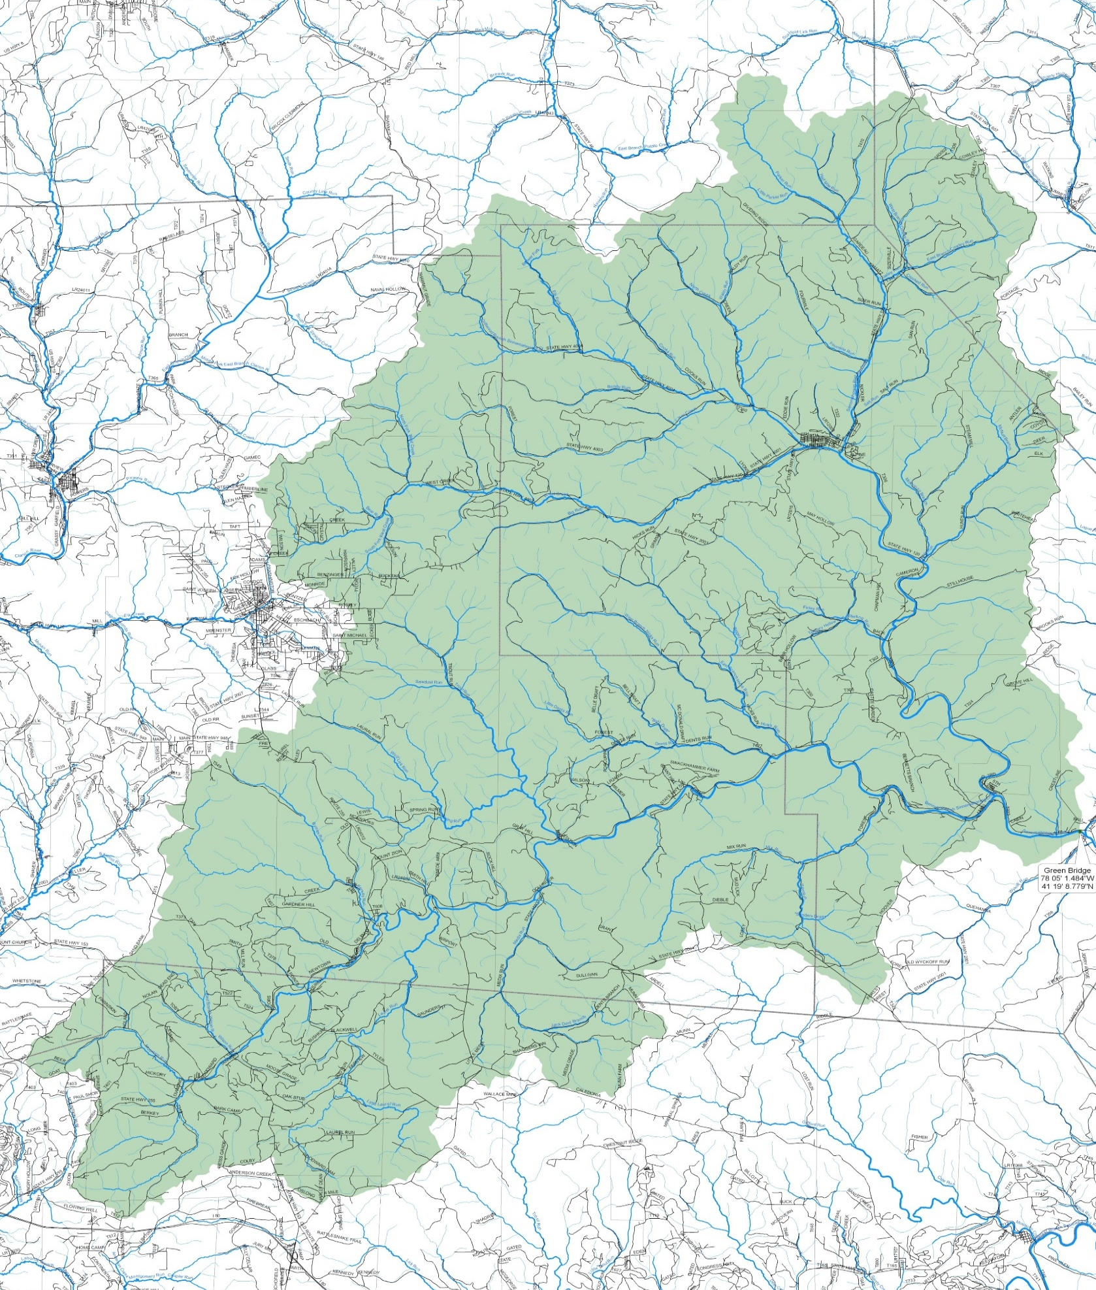

Figure 1. Sinnemahoning Creek Watershed

